**LABSHEET 4: ASSEMBLY LANGUAGE PROGRAMMING OF**

**8085 MICROPROCESSORS**

**__________________________________________________________________________**

**Name: Vinayak V Thayil Roll Number: AM.EN.U4CSE21161**

**___________________________________________________________________________**

**Lab Exercise:**

1. Write an assembly language program to check whether the number stored in memory location 4500H is even or odd. If the number is even, find the sum of 10 numbers stored in the consecutive memory locations starting from 2000H. If the number is odd, find the average of 10 numbers stored in the consecutive memory locations starting from 2000H.

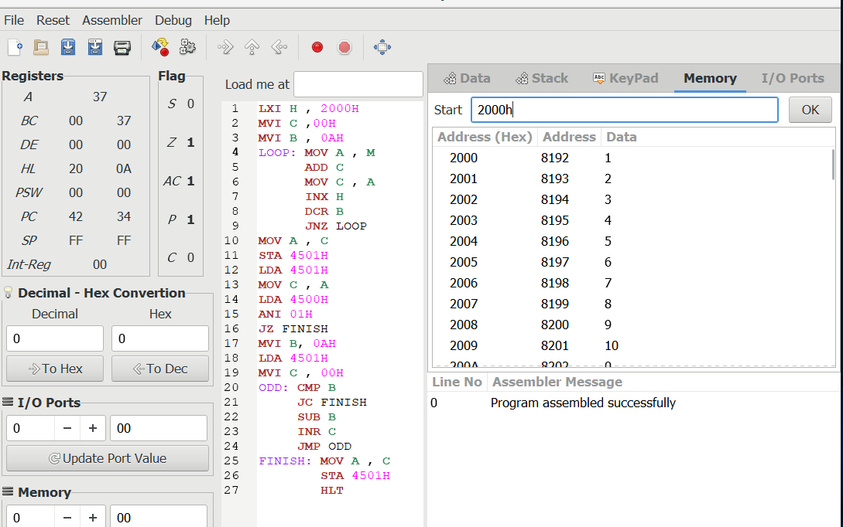

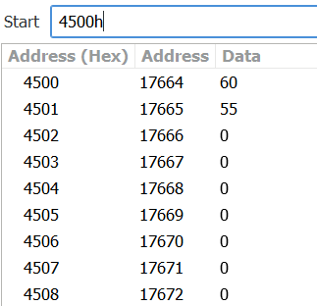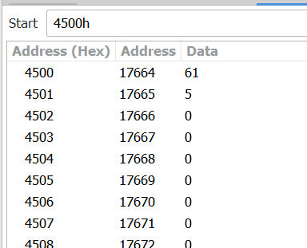

1. Write an assembly language program to find number of ‘0’ in the number stored in memory location 3500H.

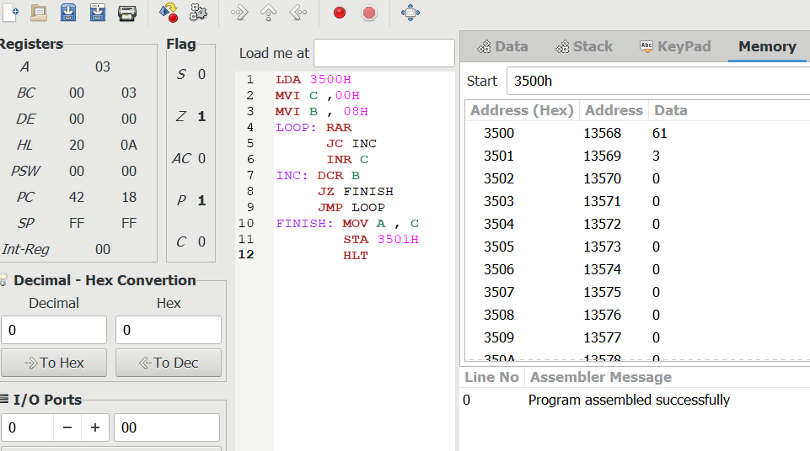

1. Design a simple calculator using 8085 which can perform the following operation. The inputs are stored in the memory location 3000H and 3001H. The output can be stored in the location 3002H.

|  |  |
| --- | --- |
| **Select** | **Operation** |
| 000 | Addition |
| 001 | Subtraction |
| 010 | Multiplication |
| 011 | Complement |
| 100 | Logical AND |
| 101 | Logical OR |
| 110 | Logical XOR |
| 111 | Previous Operation |

